Ride-on-mower equipment prescription form
General information and instructions
This form must be completed for all requests for ride-on-mowers and like vehicles e.g. side-by-side and farm utility vehicles, and related equipment e.g. tow-behind weed sprayers and trailers.
Note: any vehicle used on the Victorian road system that travels for more than two kilometers at a time in one direction is considered to be a motor vehicle. The Transport and Car Needs Assessment Form should be used for the prescription of any motor vehicle.

All questions must be answered for this plan to be considered.
Supporting evidence must be provided along with the completed form including:
- measurement recordings
- detailed site photos showing identified hazards
- photo and/or video footage of the worker trialing the equipment
- supporting ADL/home help services assessment
- all related notes

Equipment trial and site assessment must occur at the worker’s property.
Please use block letters when completing this form and attach an itemized quote for prescribed equipment.
Where there is insufficient space or for any further relevant information, please attach to the back of this form.

1. Injured worker’s details
Injured worker’s name | Claim No.
Occupation | Date of birth | Date of injury
Address

2. Summary
What equipment is being recommended? E.g. zero turn ride on lawn mower, tow behind weed sprayer
Does the equipment suit the injured worker’s compensable condition? | Yes ☐ No ☐
Did the worker successfully trial the equipment at their property? | Yes ☐ No ☐

3. Recommended method of provision
☐ Purchase ☐ Hire | If hire, for how long?

4. Type of supply
☐ Initial provision ☐ Replacement

5. If existing services or equipment is being replaced
Details of existing garden maintenance services (scope, frequency and duration)
Details of existing equipment (specify type/model and date of purchase)
Specify the reason for replacement of services or equipment (limitation of current equipment)
Any further relevant information

6. Equipment recommended
Purpose of equipment recommended. Consider intended ADLs, social, intended use (frequency and size of the area to be mowed)
Expected measurable outcomes. Consider functional goals
Details of equipment recommended. List model, order code and specification. Consider sizes, standard features, and standard accessories. Consider Roll-Over Protection Structure (ROPS) and seat belt.
Are non-standard options or non-standard customisations or modifications required? Yes ☐ No ☐
If yes, please list options and supporting clinical rationale
Have you considered day to day transportation of the equipment? Yes ☐ No ☐ N/A ☐
Have you considered the compatibility with existing equipment and the injured worker’s environment? Yes ☐ No ☐
Have you considered safety of the injured worker and carers with this equipment? Yes ☐ No ☐

7. Trials and Recommendation
Please include details of all equipment trialled and include the specific item you are recommending.

Notes:
- Trials should occur on site at the worker’s property and cover the required area to mow including navigation around site hazards.
- Attach photo and/or video footage of the worker trialing the equipment
- Attach detailed site photos showing identified hazards
- The injured worker’s face must be shown in photo and video footage

EQUIPMENT TYPE/MODEL:
Trial Date:
Trial Location:
Trial Duration (in minutes):
Name of the equipment supplier representative in attendance:
Injured worker consents to video footage ☐ Yes ☐ No
Summary of trial:

RANGE OF MOVEMENT/TOLERANCES ASSESSED AT TRIAL | SUITABLE | NOT SUITABLE | NOT APPLICABLE
Able to tolerate vibration through chassis | ☐ | ☐ | ☐
Able to tolerate undulations in the paddock/yard | ☐ | ☐ | ☐
Sufficient range of upper limb movement and strength to operate steering levers | ☐ | ☐ | ☐
Spine was kept in a neutral position for the entire trial | ☐ | ☐ | ☐
Chassis to seat height suitability | ☐ | ☐ | ☐
Backrest height and shape suitability | ☐ | ☐ | ☐
Foot position suitability | ☐ | ☐ | ☐
Transfer capacity – able to transfer safely on and off the mower | ☐ | ☐ | ☐
Sufficient lower limb strength to operate the deck lifter, or the user was able to raise and lower the cutting deck using a modified lifting technique | ☐ | ☐ | ☐
Able to apply adaptive techniques and demonstrated understanding of pacing principles | ☐ | ☐ | ☐
Symptoms were stable both at the completion of the trial and 24 hours afterwards | ☐ | ☐ | ☐
ENVIRONMENTS ASSESSED AT TRIAL | COMPETENT | SAFETY CONCERNS | NOT APPLICABLE
Operating the device on different surfaces (grass, gravel, uneven ground) | ☐ | ☐ | ☐
Operating the device on inclines/declines less than 15 degrees | ☐ | ☐ | ☐
Negotiating obstacles (trees, garden beds etc.) | ☐ | ☐ | ☐
Accessing all areas of the property curtilage (areas to be mowed) | ☐ | ☐ | ☐
Negotiating gates | ☐ | ☐ | ☐
Parking and storing the mower | ☐ | ☐ | ☐
SUMMARY
Opinion: Does the mower suit the user’s compensable condition? Suitable ☐ Not suitable ☐
Are modifications required to make use/positioning suitable? Yes ☐ No ☐ (detail required modification in item 6 above)
Is the equipment recommended? Yes ☐ No ☐

RIDE ON MOWER USER SAFETY ASSESSED AT TRIAL
The following has been adapted from WorkSafe’s Safety Alert - Ride-on lawn mower roll over (26th Oct 2022). This alert states that operating a ride-on mower on steep slopes, embankments, or uneven ground poses a high risk of a roll-over, which could cause serious or fatal injuries. These can occur due to being thrown from the mower or being crushed between the overturned mower and the ground.
Personal Safety | YES | NO
Can the user safely mount/dismount the mower? | ☐ | ☐
Did the user follow instructions accurately? | ☐ | ☐
Was the user able to operate the mower without any verbal prompts to ensure safe operation? | ☐ | ☐
Was the use able to reverse the mower safely? | ☐ | ☐
Did the user slow down appropriately, including when approaching hazards, obstacles or turning corners? | ☐ | ☐
Was the user able to judge the position of the mower and maneuver it in small spaces (e.g., avoided running into other objects)? | ☐ | ☐
Was the user able to turn the mower on and off? | ☐ | ☐
Was the user able to operate the choke? | ☐ | ☐
Was the user able to adjust the speed of the mower using the rabbit and tortoise lever? | ☐ | ☐
Was the user able to turn the cutting blades on and off? | ☐ | ☐
Does the user understand and demonstrate the ability to park the mower safely? | ☐ | ☐
Does the user understand the safety feature in the seat? | ☐ | ☐
Did the user demonstrate comfort/ease in the use of the mower? (i.e., not overwhelmed, overstimulated by operations/noise or tentative with use etc.) | ☐ | ☐
Does the user own PPE and acknowledge the need to use this when operating the equipment? e.g. safety glasses, appropriate footwear (closed shoes/boots), helmet, and ear protection | ☐ | ☐
Was the user able to maintain concentration and attention throughout the trial | ☐ | ☐

Environmental Safety, Hazards and Precautions | YES | NO
Have you visually inspected the ground conditions at the user’s property to identify no-go zones such as embankments, retaining walls, steps, sink holes and/or other uneven ground? Consider obstacles that may be hidden by long grass. | ☐ | ☐
Following inspection, are there any obstacles on the property, such as those indicated below, that present a risk of mower roll-over, or ejection of the user during use?
Retaining walls | ☐ | ☐
Potholes | ☐ | ☐
Ditches | ☐ | ☐
Trenches | ☐ | ☐
Other (specify): | ☐ | ☐
Is there a need to drive the mower above or over a slope, embankment, hill, raised section of lawn, etc. with an incline of more than 15 degrees*  *Note: The manufacturer’s guidelines for the safe working incline of the recommended equipment must be considered. Most equipment can be used safely on a slope up to 15 degrees. Inclines should be measured using an appropriate slope measurement device such as an inclinometers device or phone app. | ☐ | ☐
Is there a risk of the mower rolling side-ways down an embankment or retained wall?  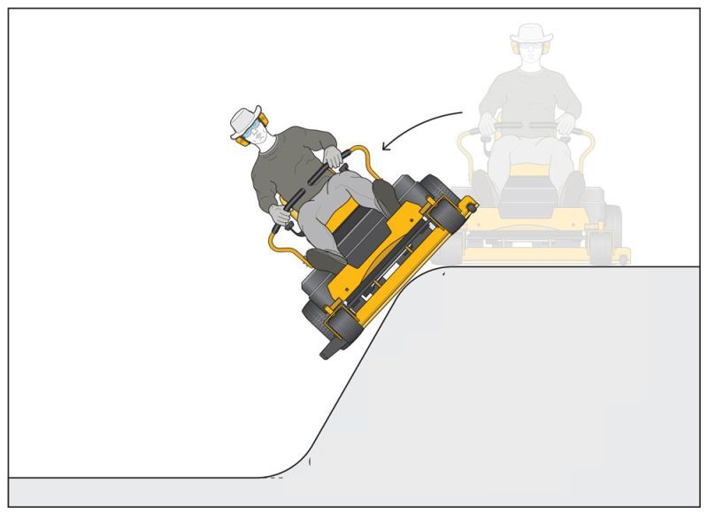 | ☐ | ☐
Google Maps aerial photograph of worker’s property showing curtilage.
[INSERT PHOTO]

Photographs of the worker’s property
[INSERT PHOTOS]

Photographs of identified environmental risks (retaining wall, potholes, ditches, trenches, other)
[INSERT PHOTOS]

Roll Over Risk | Yes | No | N/A
Has a risk of rollover been identified? | ☐ | ☐ | ☐
Can uneven ground and steep slopes be converted from grass to other types of vegetation that do not require mowing, such as a mulched garden bed? | ☐ | ☐ | ☐
Can a fence along the edge of an embankment or retaining wall be constructed to prevent ride-on mowers accessing the uneven ground or steep slope? | ☐ | ☐ | ☐
Can an alternative means of mowing, for example a brush cutter, self-propelled walk behind mower, or a weed spray unit be used to maintain the grass on any identified slope, embankment, hill, or raised section of lawn? | ☐ | ☐ | ☐
Is a ride-on mower fitted with a Roll-Over Protection Structure (ROPS) and seat belt indicated for this user? | ☐ | ☐ | ☐
Has the user been instructed to always wear the seat belt when the ROPS is secured in the up position? 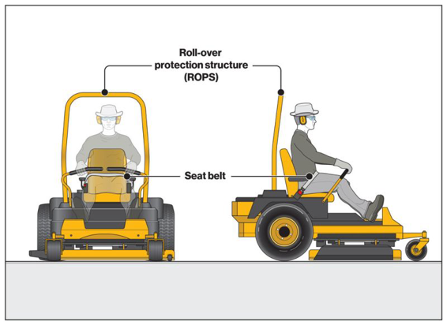 | ☐ | ☐ | ☐
Has the user been trained to plan the method of mowing to prevent turning or reversing near uneven surfaces such as embankments? | ☐ | ☐ | ☐
Has the user been instructed in continuous review of environmental conditions and assessment of ground conditions prior to use, including slope, wet grass, discharged cut grass, and hidden obstacles? | ☐ | ☐ | ☐
Has the user been instructed in the use of any tow-behind or trailer accessory to minimize the roll over risk? | ☐ | ☐ | ☐

8. Quotation
Has a written quotation been obtained? Yes ☐ No ☐
[ATTACH QUOTE]

9. Anticipated maintenance and repair
Consider warranty, suppliers recommended service schedule, manufacturer guidelines

10. Training requirements and documentation
Detail the user training requirements and methods (in person and training documentation provided)
Training should cover:
• Equipment operation
• The use of safety equipment (PPE, goggles, boots, and seatbelt)
• Assessment of environmental conditions and site prior to use (e.g. long grass hiding objects, wet grass reducing traction/increasing risk of slips, no-mow zones)
• Planning the route/method of mowing to reduce risks
• Testing brakes before commencing work
e.g. WORKER was provided with instruction and guidance on mower use on their property during the trial/s. Further set-up and orientation to the features of the mower and a skills test to ensure ongoing safe use is to be supplied on delivery along with the user documentation manual.
Is a review of the equipment upon delivery required? Yes ☐ No ☐
If no, please explain why a review is not required

Specify the user instruction and training documents provided to the worker:
Note: documented instructions should be prepared with a blank section to add specific instructions unique to the worker and their property, such as specifying hazards and areas of the property that are unsuitable for the use of a ride-on mower. Acknowledgement that instructions were demonstrated and understood must be provided below. User instruction documents must be provided to the worker and a copy provided to the Agent/WorkSafe upon request.

Acknowledgement of user instruction and training provided:
Participant | Name | Signature | Date
Injured Worker
Prescribing Therapist
Equipment Supplier Representative

11. Prescribing therapist follow up
Detail follow up services required, including user training upon delivery and review at 12 months post supply.
Explain why follow up services or training is recommended | Frequency and duration of follow up services e.g. single delivery/set-up/education session | Comments, including additional travel time

12. Additional comments and considerations
Detail additional considerations – for example:
- Equipment storage – is there a lockable area where the equipment can be stored?
- Associated costs – does the worker understand and accept that they are responsible for fuel, maintenance and servicing, parts etc.
- Contribution – if a superior model is recommended, does the worker understand and accept their required contribution?

13. Current functional status
Work-related injuries and relevant medical history.
Consider cognitive function, behaviour, and prognosis, and attached related reports.
Detail discussions held with the worker’s treating medical practitioner/s.
Consider the worker’s capacity to safely operate the recommended equipment and any the impact of current medication (e.g. may cause drowsiness)

Date | Time | Name | Role and Organisation | Discussion details and outcomes

Social situation.
Consider informal supports, living situation, employment

14. Prescribing therapist details
I have discussed the information contained in the equipment prescription form with the injured worker, carers, and other members of the treating team, including the equipment requested the aims, predicted outcomes, maintenance, and training requirements.

Prescriber Name |  | Organisation
Business address |  |  | Post Code
Phone number | Email address
Days/hours available

15. Acknowledgement
All trial participants acknowledge that they agree with the contents of this form and note any corrections below.

Role | Name | Signature | Date | Notes or corrections
Worker
Prescriber
Supplier

16. Collection of personal information
Personal and health information collected by WorkSafe on this form will be used for the purpose of processing your Equipment prescription form, as part of the management of the claim. It may be used for other related purposes including administration and evaluation of WorkSafe’s programs.
WorkSafe may disclose any personal and health information it collects to its authorised agents, legal practitioners, contractors, consultants, and other service providers engaged by it or by its authorised agents; courts tribunals; the Accident Compensation Conciliation Services, or any other person or organisation authorised by you, or law to obtain it.
Individuals have the right to access their personal information held by WorkSafe. You should contact WorkSafe’s Freedom of Information Unit. You can access the WorkSafe privacy policy at worksafe.vic.gov.au

